**Interest Rate Effects On Currency Trades**

Interest Rate Effects On Currency Trades

Smart Money Accumulation & Distribution [Fundamentally Speaking)

Interest Rates are the single most influential driving force behind market moves. Understanding Interest Rate Shifts & changes can assist you in selecting trades. Technical Analysis of key Interest Rates can unlock professional money movement. Interest Triads provide a visual depiction of Smart Money Accumulation & Distribution.

B Interest Rate Triads

30 Year Bond - Key Long Term Interest Rate. 10 Year Note - Intermediate Term Interest Rate. 5 Year Note - Short Term Interest Rate.

Overlaying or Comparative Analysis on these three Interest Rates unlocks Price Action. Failure Swings at opportunistic times can validate Institutional Order Flow.

  **ey s e** •**ce**

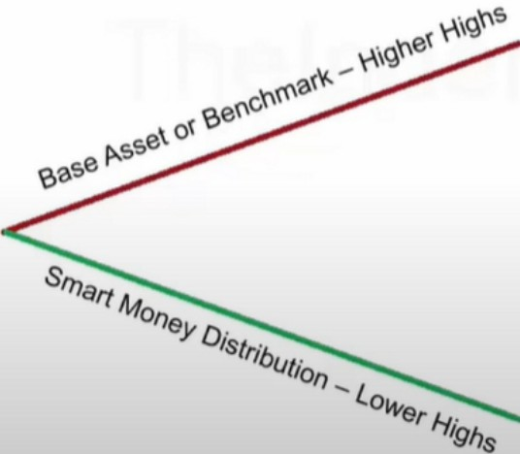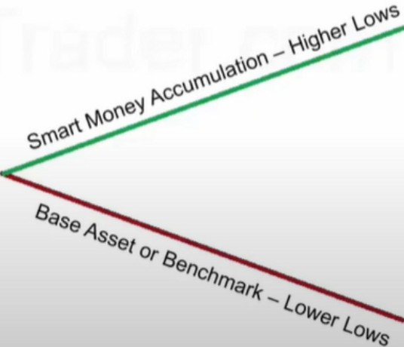**In B arlsh Condltlo In Bullish Conditions**

To accumulate more of it, they will force it into premium, it wont go into discount

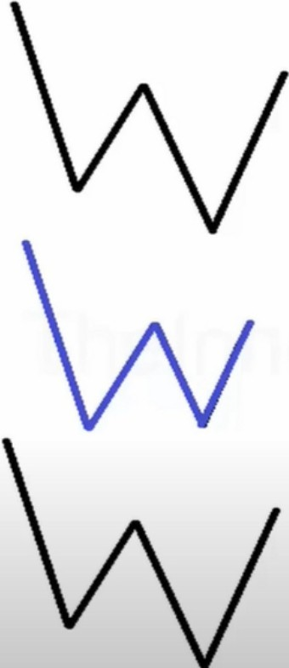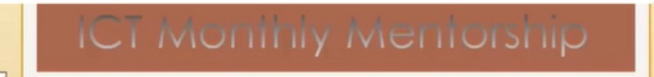

I **J.**

**J.**

**Triad**

**30 Year T Bond Market 10 Year Note Market**

**5 Year Note Market**

Overlaying these three markets will highlight when Accumulation & Distribution in the Interest Rate Market takes place - from a "Smart Money" perspective.

The three Interest Rates should confirm each higher high or lower low - at moments when the USDX is at a significant Price point.

Failure swings highlight Smart Money participation in the markets & trading opportunities are validated.

This confirms a bullish orderblock for the dollar index

Justifying a long on the dollar - lower high on the 30 year bond market a swing failure Interest rates are the number 1 drivers of the currency market

If theres a divergence between the 3 and dollar gives you an orderblock to trade off, that gives you the green light to trade it, thats high probability

*-------------------- ,......*

**ZBH17 • T-Bond • 90 Minute Line Chart**

* **ZBH17 148-15**

**lU<)0**

**152·2'**

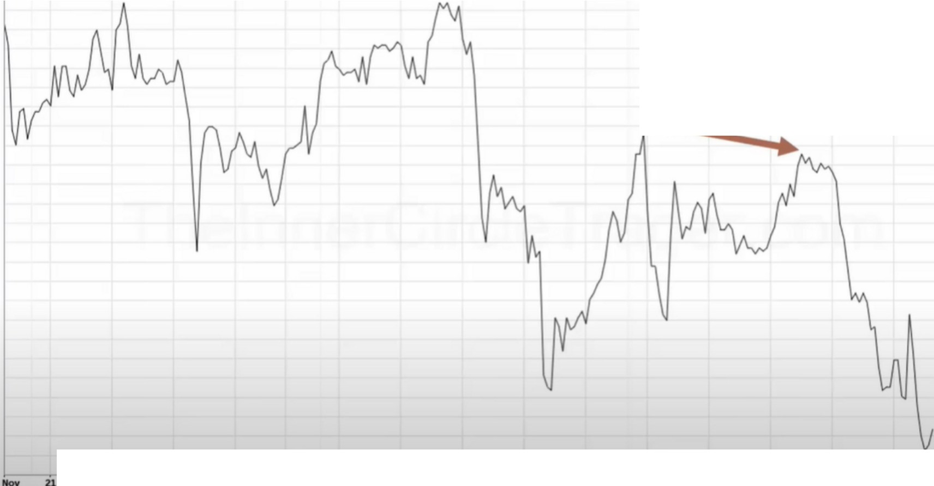

--

**23**

is *ie*

ii

**ll>oc**

**5**

;,

..

**152·19**

**152·11**

**152...**

**152-00**

**151·2'**

**151•19**

**151·13**

**151...**

**151-00**

**150-2'**

**150-11**

**150-ll**

1-

**15<><10**

**1..9-26**

**149-19**

,**1**.**4**..**9**.**-l**.**l**

-

,.....

**148-2'**

**148-19**

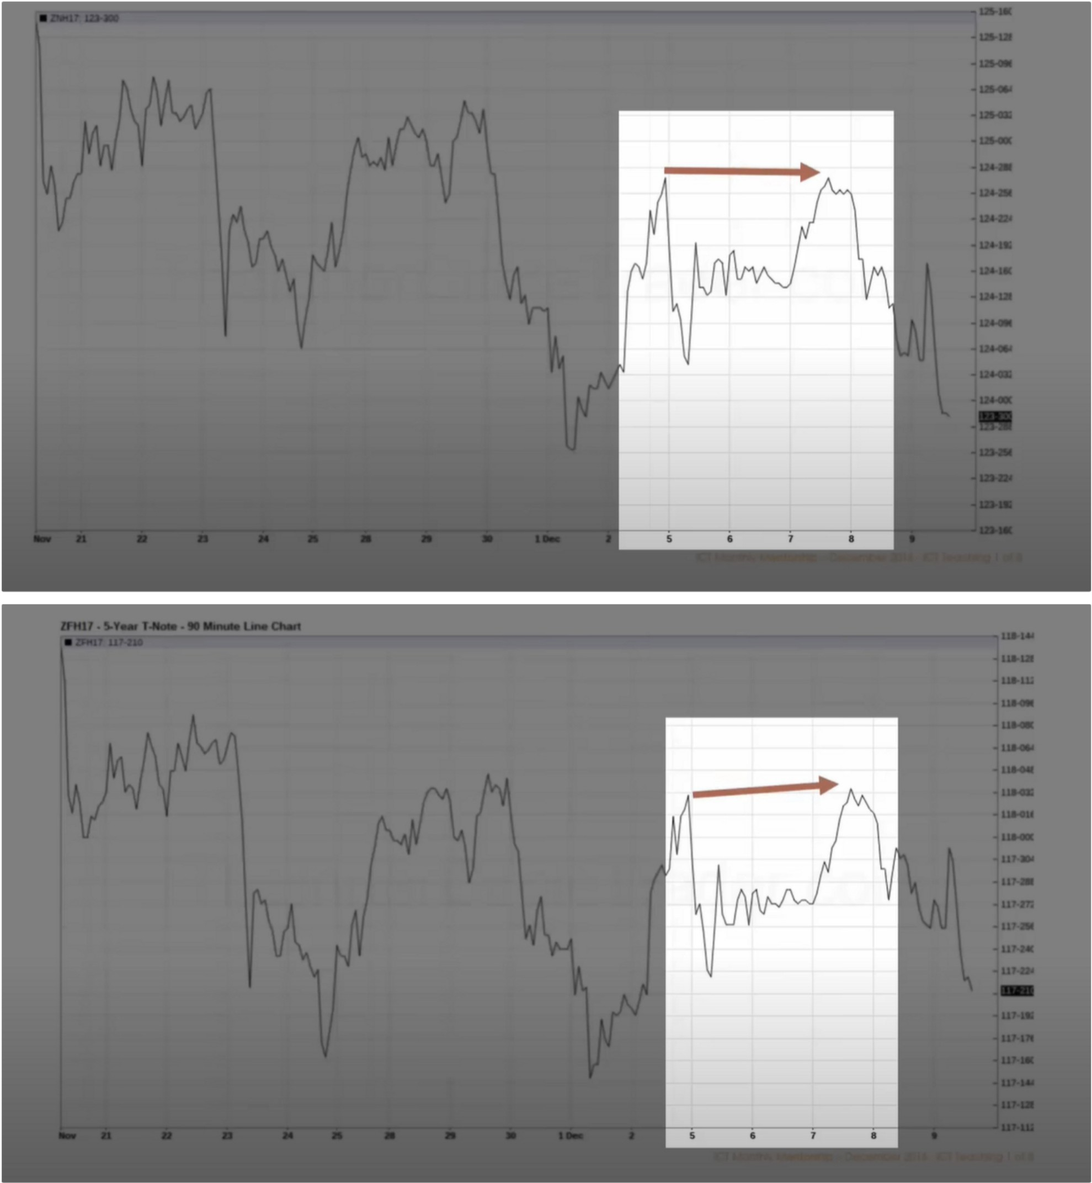

This highlights theres a shift in the interest rate market

**OXYOO - U.S. Dollar Index • 90 Minute Line Chart**

* **DXYOO 101.570 102.100**

**102000**

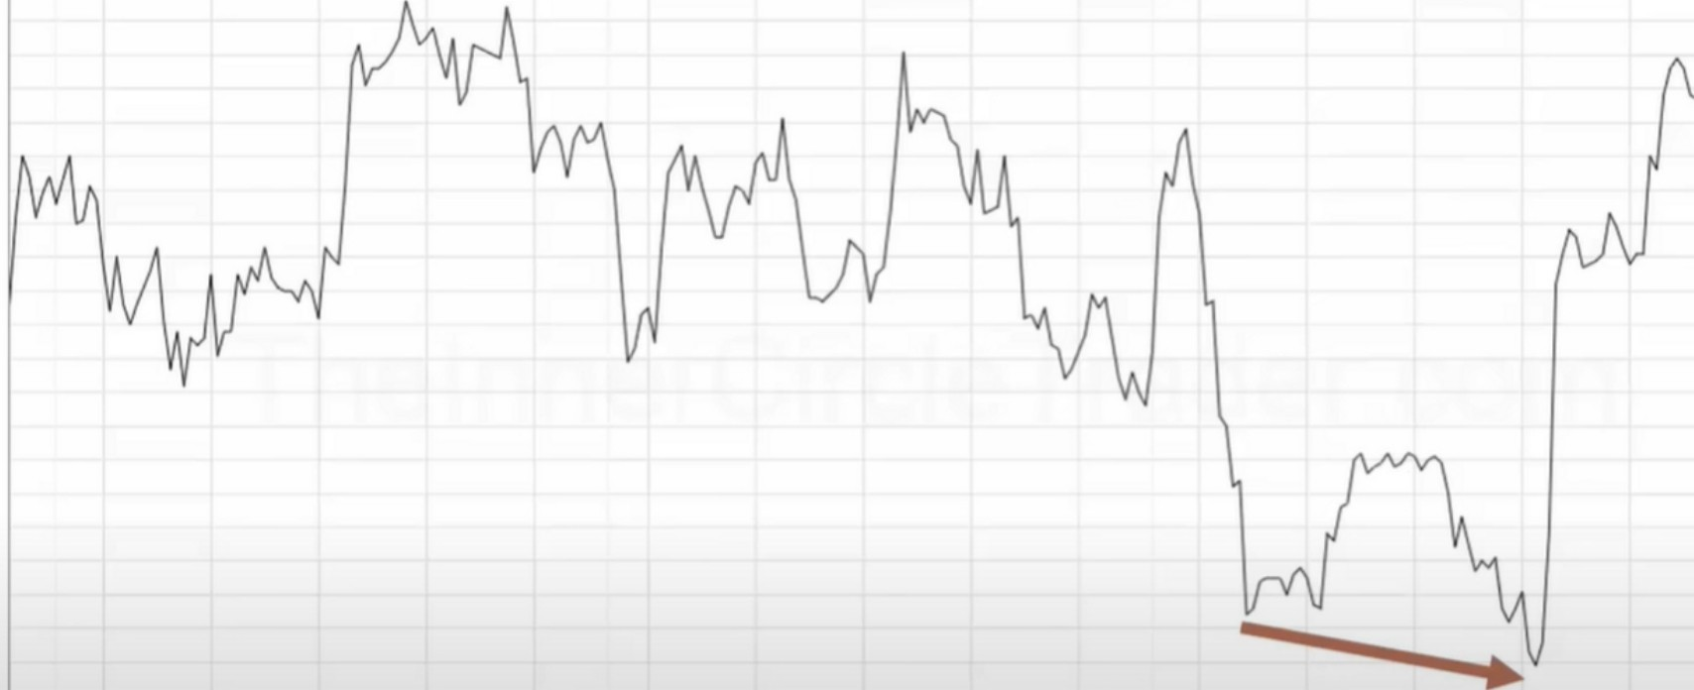**101.900**

**101100**

**101700**

**llilllii**

**101-500**

**101.400**

**101 aoo**

**101200**

**101100**

**101000**

**100900**

**100800**

**100700**

**100000**

**100500**

**100<00**

**100300**

**100200**

**100100**

.**1**.**9**.**9**.**0**.**0**

**100000**

**19700**

,... --.,-- i:z

**23**

is

io

**lDoc**

.....

**19000**

**19500**

**OXYOO. U.S. Dollar Index - 90 Minute Line Chart**

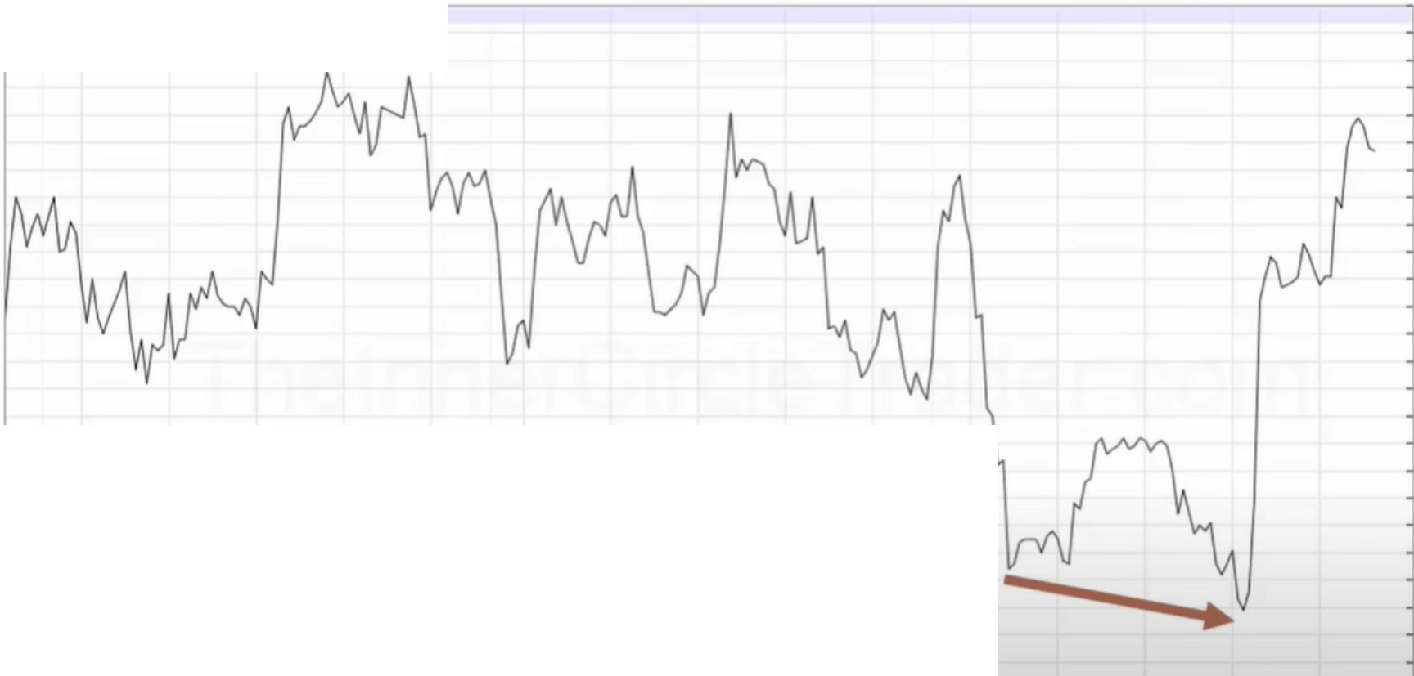

.....

**99700**

,

...

Order Flow - Anticipate Dynamic Movement

**21**

*i:,*

**23**

is

**,i**

**lOee**

.....

**19000**

--.

**19500**

When Price Moves Into Previous Levels of Institutional

|  |  |  |
| --- | --- | --- |
| * **0XY00'101570** |  | **102.100** |
|  | | **102.000** |
| **101.900** |
| **101100** |
| **101700** |
| **llillllll 101500** |
| **101.400** |
| **l0U00** |
| **101200** |
| **101100** |
| **101000** |
| **100000** |
| **100000** |
| **100700** |
| **100000** |
| **100500** |
| **100<00** |
| **100300** |
| **100200** |
| **100100** |
| **100000** |

So combine this with PD arrays and this is how you know if a PD array will hold

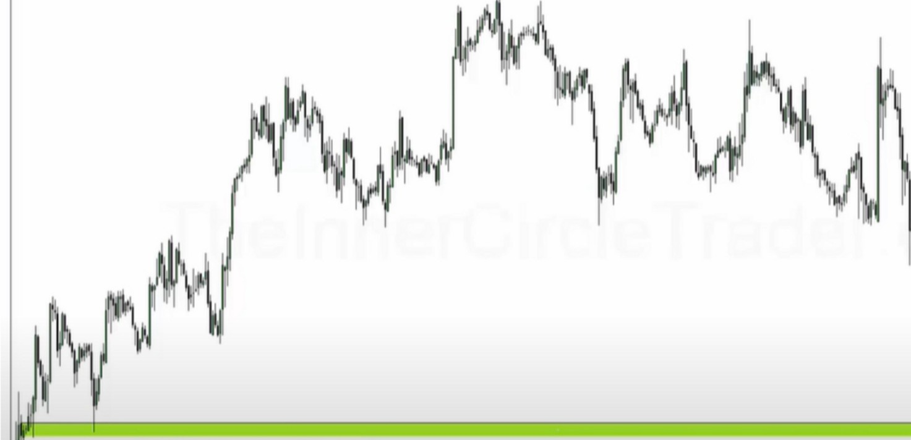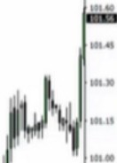

**Previous Bullish Orderblock**

..

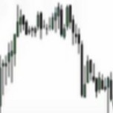

*=•-=-*•=--=•=--=•""""--=•-=-=,.-=.-.-==-=•-=-=--=--=-=.,=. -=-=•-=-=-=-**=--=--==--=-=-=-=-=-=-=,k- k-=-ck=-,--,-,k=-=k=••=k=--=k-=k•.,,..-,,·=k,,_:-r.k_**

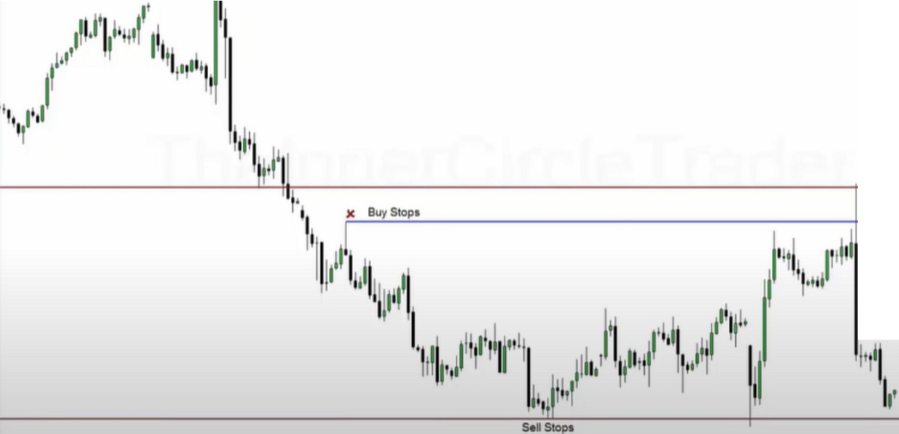

You have to blend a couple things sometimes to know what smart money is doing, so multiple assets





*,!'* ..

I._,.. I , ,, 1-., I I l I II/ I,, 1.........,1 I I "-"1 _,I II,. ,

**Use the points of Focus taught in the first month of the Mentorship.**

**When Price Action trade to a Focus Point like a:**

**Orderblock Liquidity Pool**

**Liquidity Void or Fair Value Gap**

**Refer to the Interest Rate Triad** & **USDX to confirm Smart Money is behind your trade idea. If there is no obvious indication they are moving large funds** - **pass on the trade idea and look for new ones that do.**

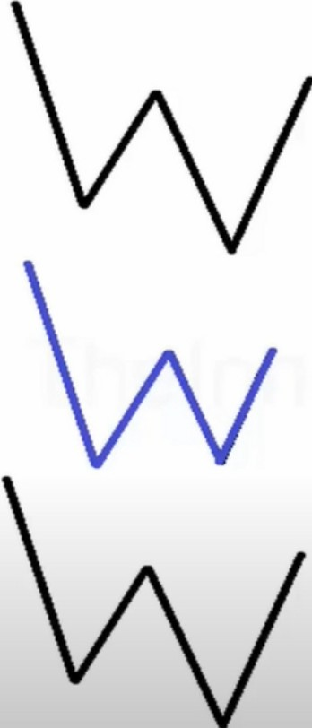When this happens, look to sell the dollar. And we can confirm a bearish orderblock or an old high on the dollar

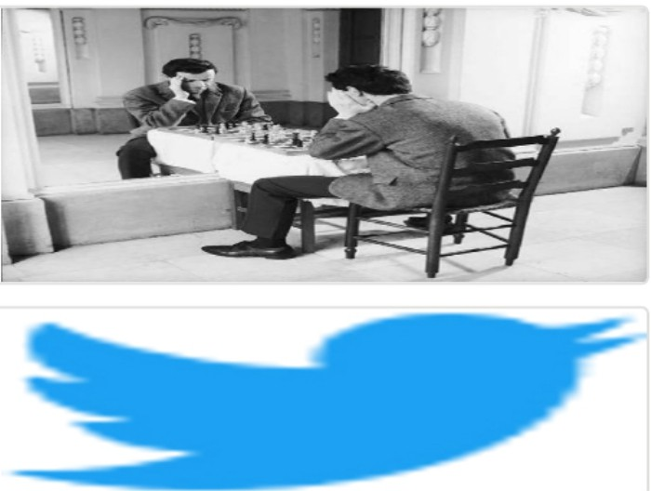Arjo I Twitter, lnstagram I Linktree

Linktree. Make your link do more.

, https://t.co/HhmmTN1fUI

JavaScript is not available.

**'If#** https://twitter.com/arjoio